|  |  |
| --- | --- |
|  | **ATAR Physics Year 12**  **Semester Two Examination, 2016**  **Question/Answer Booklet** |

Student Name: ___________________________________

**Time allowed for this paper**

Reading time before commencing work: 10 minutes

Working time for paper: 3 hours

**Materials required/recommended for this paper**

***To be provided by the supervisor***

This Question/Answer Booklet and the Formulae and Constants Sheet

***To be provided by the candidate***

Standard items: pens (blue/black preferred), pencils (including coloured), sharpener, correction tape/fluid, eraser, ruler, highlighters

Special items: non-programmable calculators approved for use in the WACE examinations, drawing templates, drawing compass and a protractor

**Important note to candidates**

No other items may be taken into the examination room. It is your responsibility to ensure that you do not have any unauthorised notes or other items of a non-personal nature in the examination room. If you have any unauthorised material with you, hand it to the supervisor before reading any further.

**Structure of this paper**

|  |  |  |  |  |  |
| --- | --- | --- | --- | --- | --- |
| **Section** | Number of questions available | Number of questions to be answered | Suggested working time (minutes) | Marks available | **Marks Attained** |
| Section One: Short answers | 13 | 13 | 54 | 54 (30%) | /54 |
| Section Two: Problem-solving | 7 | 7 | 90 | 90 (50%) | /90 |
| Section Three: Comprehension | 2 | 2 | 36 | 36 (20%) | /36 |
|  |  |  |  | 180 (100%) | /180 |

**Instructions to candidates**

Write your answers in the spaces provided beneath each question. The value of each question (out of 150) is shown following each question.

The enclosed Physics: Formulae and Constants Sheet may be removed from the booklet and used as required.

Calculators satisfying conditions set by the Curriculum Council may be used to evaluate numerical answers.

Answers to questions involving calculations should be evaluated and given in decimal form.

Give final answers to three significant figures and include appropriate units where applicable.

When calculating numerical answers, show your working or reasoning clearly. Despite an incorrect final answer, credit may be obtained for method and working, providing this is clearly and legibly set out.

Questions containing specific instructions to **show working** should be answered with a complete, logical, clear sequence of reasoning showing how the final answer was arrived at; correct answers which do not show working will not be awarded full marks.

Questions containing the instruction **estimate** may give insufficient numerical data for their solution. Students should provide appropriate figures to enable an approximate solution to be obtained. When estimating numerical answers, show your working or reasoning clearly. Give final answers to a maximum of two significant figures and include appropriate units where applicable.

**SECTION ONE: Short Response 54 marks (30%)**

This section has **15** questions. Answer **ALL** questions. Write your answers in the spaces provided.

Spare pages are included at the end of this booklet. They can be used for planning your responses and/or as additional space if required to continue an answer.

* Planning: If you use the spare pages for planning, indicate this clearly at the top of the page.
* Continuing an answer: If you need to use the space to continue an answer, indicate in the original answer space where the answer is continued, i.e. give the page number.

Fill in the number of the question(s) that you are continuing to answer at the top of the page.

Suggested working time for this section is **50 minutes.**

**Question 1 (3 marks)**

The two spheres A and B below are both given a charge *+Q*. They are separated by a distance *r*. The repulsive force between them is *F.*

A B

*+Q*

*+Q*

*F*

*F*

*r*

When the charge on A is doubled the repulsive force between them is

doubled halved unchanged (circle the correct response). (1 mark)

When the charge on both spheres is doubled the repulsive force (compared to *F*) is

doubled increased by a factor of four increased by a factor of eight (1 mark)

(circle the correct response)

When the charge on both sphere is *+Q*, but the separation of the spheres is doubled to 2r, the repulsive force (compared to *F*) is

unchanged decreased by a factor of two decreased by a factor of four (1 mark)

(circle the correct response)

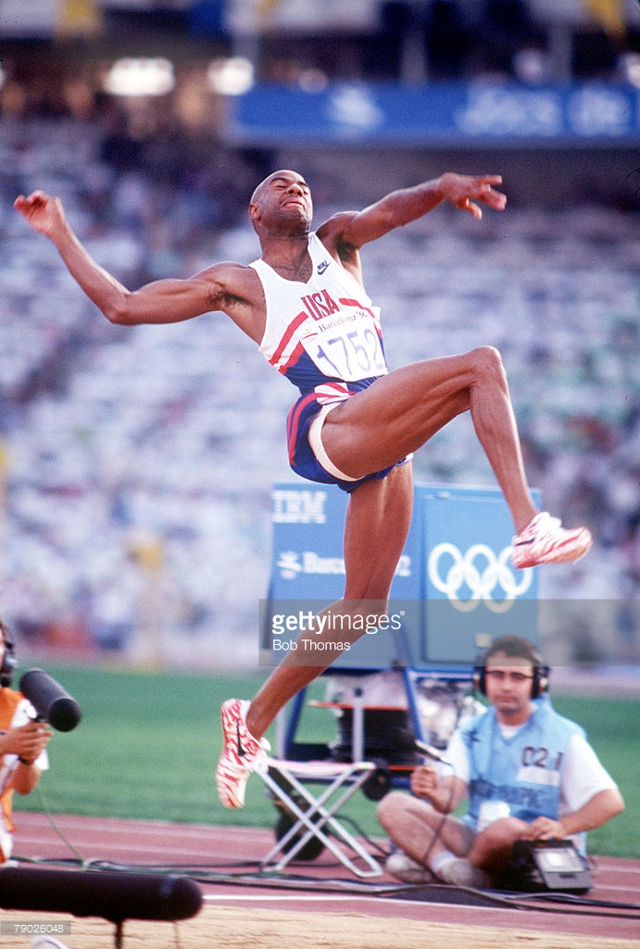**Question 2 (4 marks)**

A long jumper at the Rio Olympics launches himself into the air at a speed of 11.0 m/s and an angle of 22.5° to the horizontal in an attempt to beat the long distance world record of 8.95 metres. Show by calculation whether or not he is successful.

**Question 3 (4 marks)**

The relatively nearby star Tau Ceti, lies 11.9 light-years from Earth. An interstellar spaceship from Earth is travelling to Tau Ceti at 90% of the speed of light.

(a) How far away is Tau Ceti (in light-years) to the astronauts on the spaceship? (2 marks)

Distance ______________light years

(b) How long will the spaceship take to reach Tau Ceti

(i) from the reference frame of the astronauts on the spaceship? (1 mark)

Time _________________________years

(ii) from the reference frame of observers on Earth? (1 mark)

Time ________________________years

**Question 4 (3 marks)**

The diagram below illustrates Young’s double-slit experiment. Briefly describe the experiment, what is observed on the screen, and what we can infer about the nature of light from the observations. 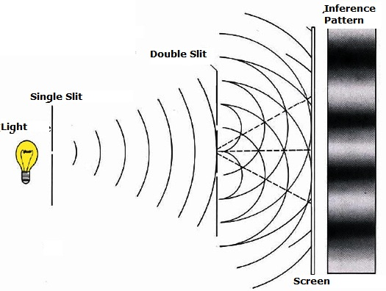

**Question 5 (5 marks)**

A satellite orbits the Earth in a circular orbit at an altitude of 4000 km. Calculate

(a) the centripetal acceleration experienced by the satellite. (3 marks)

Acceleration ______________ m s-2

(b) the orbital speed of the satellite. (2 marks)

Speed ____________________ m s-1

**Question 6 (4 marks)**

The diagram below show a long straight vertical wire (diagram A) an arrow indicates the direction of the current through the wire.

**A**

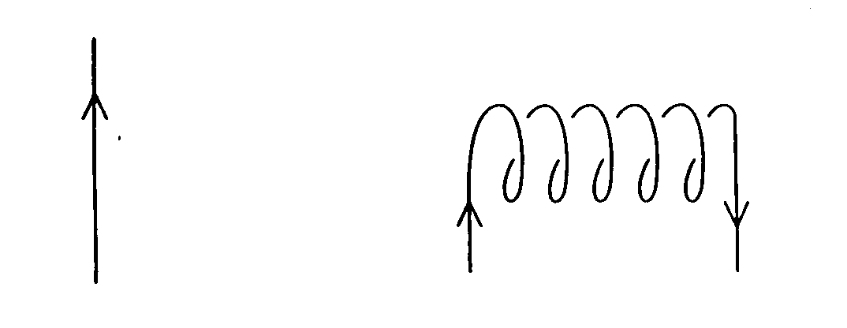

(a) Sketch on the diagram the magnetic field produced by the current in the wire. (2 marks)

(b) The magnetic field strength is found to be 45 T at a perpendicular distance of 1.75 cm from the long straight wire. Calculate the size of the current in the wire. (2 marks)

Current ____________A

**Question 7 (4 marks)**

A proton is accelerated in the Large Hadron Collider at CERN in Geneva up to 99.995% of the speed of light. At this speed, calculate

(a) the momentum of the proton (2 marks)

Momentum _________________ kg m s-1

(b) the wavelength of the proton (2 marks)

Wavelength ______________ m

**Question 8 (4 marks)**

The diagrams below show the interaction between a bar magnet and a solenoid in three different situations. The needle of the galvanometer, shown below the solenoid, indicates any flow of current.

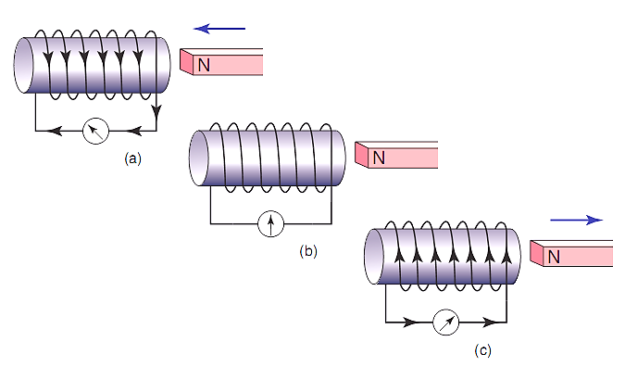

Briefly explain the following observations:

(a) No current flows (diagram b) when the magnet is held stationary near the solenoid. (1 mark)

(b) The current flows in opposite directions in diagrams (a) and (c) when the magnet is pushed towards, then pulled away from the solenoid. (3 marks)

**Question 9 (4 marks)**

A photoelectric cell contains an aluminium electrode that is illuminated with ultraviolet light of wavelength 284 nm. The work function of aluminium is 4.08 eV. Calculate the kinetic energy of the emitted photoelectrons.

Kinetic Energy ________________ J

**Question 10 (6 marks)**

A roller coaster car with three passengers has a total mass of 9.73 x 102 kg. The participants experience being upside down at the top of the circular track of a “loop the loop” showground ride. The centre of mass of the car and passengers is 15.3 m from the bottom of the ride. It is travelling at a constant speed of 12.3 m s–1.

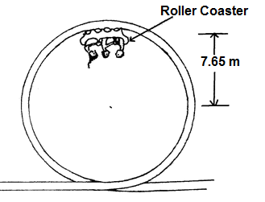

1. On the diagram above **draw** an arrow to show the direction of the force of the rail acting on the car and passengers. (1 mark)
2. Calculate the magnitude of the force that the rails at the top of the ride exerts on the car and passengers. (5 marks)

Force _______________ N

**Question 11 (4 marks)**

Observations of the luminosity of a supernova in a distant galaxy indicate that it is 1.6 × 108 light years away from Earth. Analysis of the helium spectrum from the supernova shows that the yellow line that usually occurs at a wavelength of 587.6 nm was measured for this galaxy to be at 595.3 nm. This indicates that the supernova and galaxy are moving with a velocity of 1% of the speed of light.

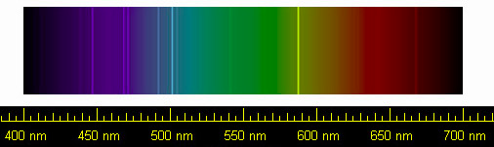

Explain what has caused the yellow line to be recorded at a longer wavelength and how this provides evidence for the Big Bang Model for the origins of the Universe.

**Question 12 (5 marks)**

An electron is fired into a uniform perpendicular magnetic field of strength 230 μT and follows a semi-circular path through the magnetic field of radius 350 mm, as illustrated at right.

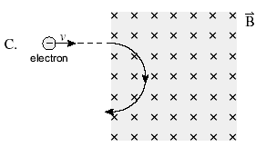

(a) Calculate the speed of the electron in the magnetic field. (2 marks)

(b) Determine the potential difference through which the electron was accelerated from rest (before reaching the magnetic field) in order to have this speed. (3 marks)

**Question 13 (4 marks)**

A block of mass 12.0 kg is sliding down a rough inclined plane. The angle of inclination is 38.0⁰ and the force of friction acting on the block from the plane is 24.4 N.

38.0⁰

Calculate the acceleration of the block down the inclined plane.

Acceleration ___________ m s-2

**End of Section One**

**SECTION TWO: Problem-solving** **90 marks (50%)**

This section has **7** questions. Answer **ALL** questions. Write your answers in the spaces provided.

Spare pages are included at the end of this booklet. They can be used for planning your responses and/or as additional space if required to continue an answer.

* Planning: If you use the spare pages for planning, indicate this clearly at the top of the page.
* Continuing an answer: If you need to use the space to continue an answer, indicate in the original answer space where the answer is continued, i.e. give the page number. Fill in the number of the question(s) that you are continuing to answer at the top of the page.

Suggested working time for this section is **90 minutes.**

**Question 14 (13 marks)**

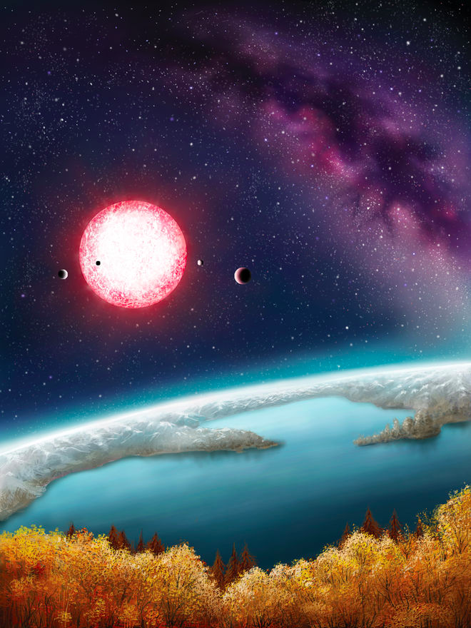Kepler-186f is one of five planets found in an extrasolar system located about 490 light-years from Earth. The newly discovered exoplanet orbits about 52.4 million kilometres from its sun. It takes Kepler-186f about 130 days to orbit its red dwarf star. Kepler-186f is the first Earth-size alien planet found in the habitable zone of its star. That means the planet, which is about 10% larger in diameter than Earth, is in the part of its solar system where liquid water could exist on the planet's surface. An artist’s impression of the planet’s surface is shown at right.

(a) What is the orbital speed of Kepler-186f?

(2 marks)

Speed _________________ m s-1

(b) Is Kepler-186f accelerating? Explain. (2 marks)

(c) From the orbital data about Kepler-186f and your answer to part (a), calculate the mass of its red dwarf sun. (3 marks)

Mass _________________ kg

(d) Kepler -186f has a diameter approximately 10% larger than Earth’s. Assuming that Kepler-186f has a similar density to Earth, determine a value for its mass based upon the estimate of its size given above. Express your answer using appropriate significant figures. (3 marks)

Mass ___________________ kg

(e) Calculate a value for the gravitational force between Kepler-186f and its sun. (3 marks)

Force ________________________ N

**Question 15 (8 marks)**

The series of diagrams below show a very fast train, with a woman standing on an open carriage, speeding at a relativistic velocity past a man standing on the ground next to the train tracks. Just as the train passes the man, two bolts of lightning strike the front and rear of the train. The woman observes that the lightning strike at the front of the train occurs before that on the rear.

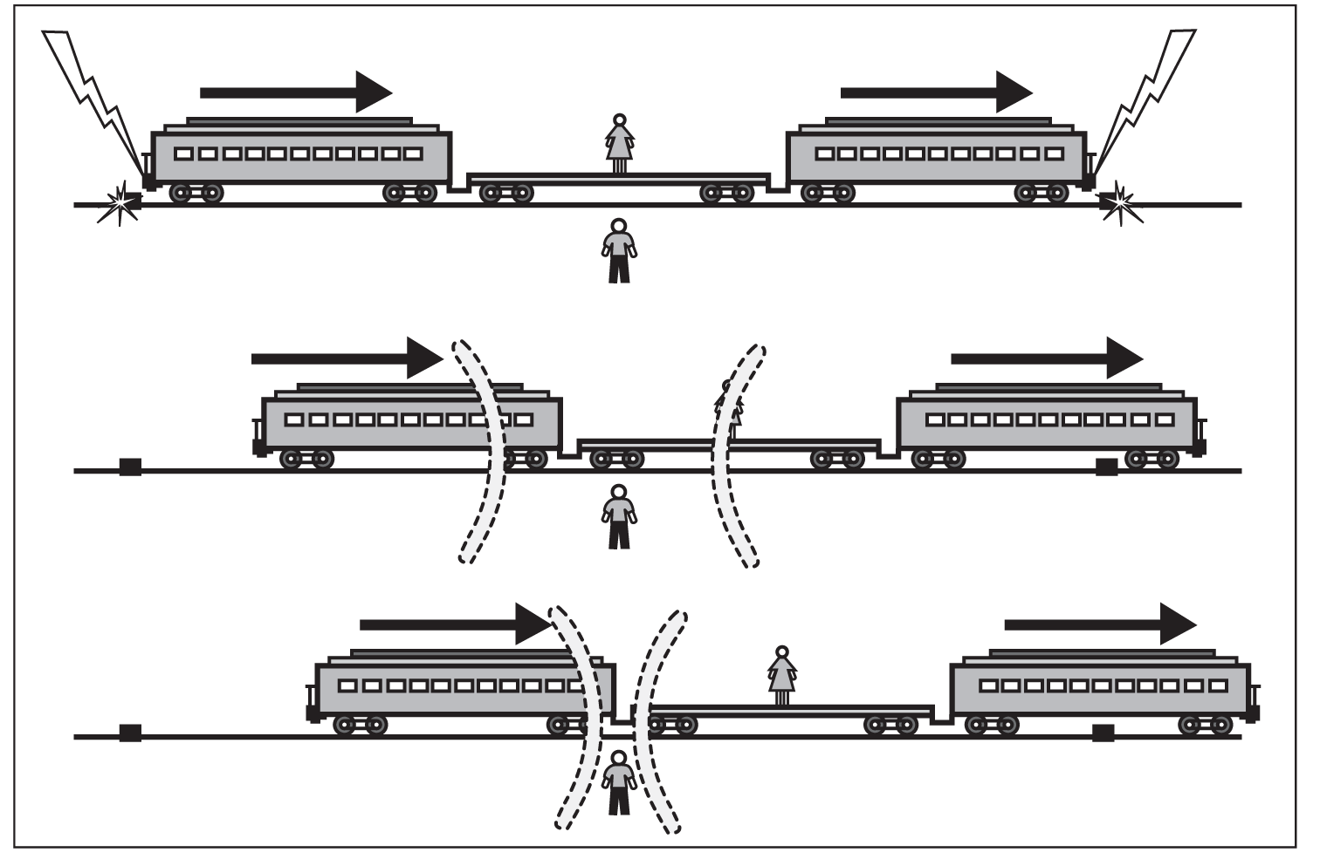

(a) What is the order in time of the two lightning strikes according to the man standing on the ground? (1 mark)

(b) Whose interpretation of events is correct, the man’s or the woman’s? Briefly explain. (2 marks)

(c) How do you explain the woman’s observations? (2 marks)

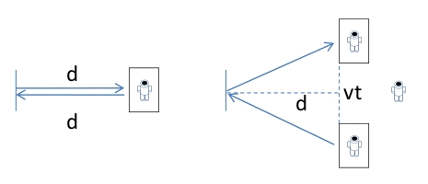In a futuristic scenario, an astronaut aboard a spacecraft travelling at a speed of close to the speed of light conducts a simple experiment (diagram A), by shining a beam of light onto a mirror that is a distance d away, and timing how long the reflection takes to return to her. Her value for the time taken by the light to travel to the mirror and back is

External

astronaut

Direction of spacecraft

A

B

t0 = 2d/c (equation 1)

While she conducts this simple experiment, a second astronaut external to the spacecraft observes the experiment as the spacecraft speeds past at velocity v. He sees the beam of light follow the path shown in diagram B due to the motion of the spacecraft.

(c) Show that the time he measures for the light travelling to the mirror and back is given by the expression. You must show all the steps in your reasoning. (3 marks)

(equation 2)

**Question 16 (12 marks)**

The diagram below shows an iron-cored transformer

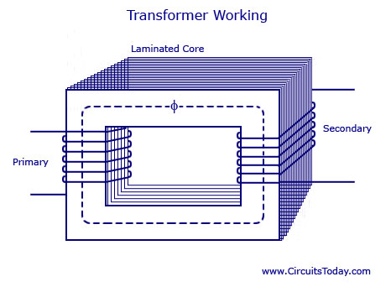

(a) The primary coil is connected to an alternating current. Explain how energy is transferred from the primary coil to the secondary coil, with reference to *Faraday’s Law of* *electromagnetic induction.* (4 marks)

(b) What is a ***laminated*** core, and what is its purpose? (2 marks)

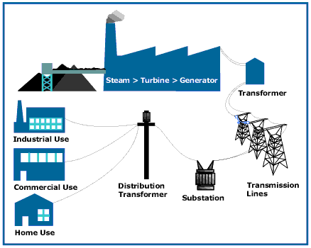In order to transmit electric power more efficiently, an electricity company uses transformers and high voltage transmission lines to transmit power at 330 kV from the power station to the city 200 km away. The average output power of its generators is 600 MW. The high voltage transmission lines have a total resistance of

5.00 Ω over their 200 km length.

(c) Calculate the voltage at the end of the transmission lines (before the substation) after transmission along the high voltage lines? (4 marks)

Voltage ________________ V

(d) Calculate the percentage power loss in the high voltage transmission lines. (2 marks)

% loss ______________________

**Question 17 (14 marks)**

Fermions are matter particles in the Standard Model. Leptons and Quarks are Fermions.

Hadrons are made from quarks. A Baryon is made from 3 quarks and a Meson from 2 quarks.

The anti-particle versions of Leptons each have a Lepton number of -1 and opposite charge.

All Leptons have a Baryon number of zero.

Tables of some particles and their properties are shown below.

|  |  |  |  |
| --- | --- | --- | --- |
| **Lepton** | **Charge (qe)** | **Lepton number** | **Baryon Number** |
| Electron | -1 | 1 | 0 |
| Electron-neutrino | 0 | 1 | 0 |
| Muon | -1 | 1 | 0 |
| Muon-neutrino | 0 | 1 | 0 |
| Tau | -1 | 1 | 0 |
| Tau-neutrino | 0 | 1 | 0 |

|  |  |  |
| --- | --- | --- |
| **Quark** | **Charge (qe)** | **Baryon number** |
| Up (u) |  |  |
| Down (d) |  |  |
| Top (t) |  |  |
| Bottom (b) |  |  |
| Charm (c) |  |  |
| Strange (s) |  |  |

|  |  |  |  |  |
| --- | --- | --- | --- | --- |
| **Hadron** | **Quarks** | **Mass**  **(MeV/c2)** | **Baryon Number** | **Lepton number** |
| Proton |  | 938.3 | +1 | 0 |
| Neutron |  | 939.6 |  | 0 |
| Pion-plus (π+) |  | 139.6 | 0 | 0 |
| Sigma-plus |  | 1189.4 | +1 | 0 |
| Charmed Omega |  | 1672.0 | +1 | 0 |

1. List two ways that a lepton differs from a quark. (2 marks)

1. Determine the Baryon number of a neutron. Show your working. (1 mark)
2. Determine the electric charge of a Charmed-Omega hadron. Show your working. (2 marks)
3. Consider the proposed reactions below –

A proton decays to a positron and a pion-plus meson

A neutron decays to a proton, an electron and an anti-neutrino.

Using your knowledge of conservation laws in the Standard Model determine whether the reactions can occur or not. Show all your reasoning. (6 marks)

1. Determine the mass of a Charmed-omega hadron in kilograms using scientific notation to 3 significant figures. (3 marks)

Mass _____________________ kg

**Question 18 (17 marks)**

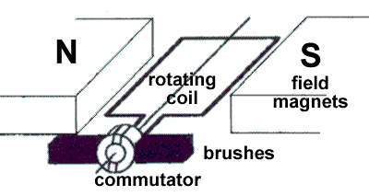A typical DC electric motor is shown at right. The coil contains 250 turns and has dimensions of 8.00 cm in length by 5.00 cm in width. The field magnets produce a uniform magnetic field of strength 0.0240 T in which the coil rotates.

(a) Explain the purpose of the commutator and brushes. (2 marks)

(b) Describe two ways that an *actual* electric motor would differ from the one shown in the diagram above. (2 marks)

(c) When in operation under load, the motor rotates at a steady rate of 750 rpm (revolutions per minute) and draws a current of 3.00 A. On the axes below, sketch the torque produced by the motor over a full rotation of the coil, starting from the position shown in the diagram above. Include appropriate scales on both axes. (6 marks)

(d) Even when under no load at all, the motor has a maximum rotational speed that it can reach. Explain why this is so, with reference to Faraday’s Law and Lenz’s Law. (4 marks)

(e) Determine the maximum rotational speed of the motor (in rpm) when connected to a 6.00 V battery and operating under no load. (3 marks)

Rotational speed _______________rpm

**Question 19 (12 marks)**

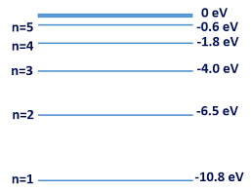The figure at right illustrates some of the valence electron energy levels in a gaseous atom of a particular element. The energies of the levels are given in electron volts (eV).

(a) The valence electron of the atom is in the lowest energy level shown. What is the ionisation energy of the atom in joules? (2 marks)

Ionisation energy _________________ J

(b) State two physical processes by which an electron in the ground state can move to a higher energy level. (2 marks)

A cold gaseous sample of the element is bombarded by electrons of energy 9.5 eV and observed to emit electromagnetic radiation.

(c) Show on the diagram above the energy level transitions that cause this emission of electromagnetic radiation. (2 marks)

(d) Calculate the longest wavelength of the emitted electromagnetic radiation. (3 marks)

Wavelength _______________ m

Invisible ultraviolet light of photon energy 6.8 eV is shone through a cold gaseous sample of the element, which then fluoresces and is observed to glow with a turquoise-blue light.

(e) Calculate the frequency of the turquoise-blue light. (3 marks)

Frequency ___________________ Hz

**Question 20 (14 marks)**

A mobile crane is used to lift a load m of mass 1600 kg, as shown in the diagram below. The 18 m long boom (crane arm) has a mass of 850 kg, centred halfway along its length, and can pivot about point P at its base.

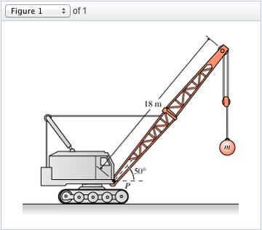

(a) Clearly show all forces acting on the boom as labelled arrows on the diagram. (2marks)

(b) A horizontal steel cable connects to the boom 8.00 m from the pivot P. Show that the tension in the cable needed to hold the boom stationary is 37 500 N. (4 marks)

(c) Determine the magnitude and direction of the reaction force provided by the pivot P on the boom. (4 marks)

Magnitude _________________ N

Direction _____________________°

(d) The boom is lifted to a more vertical position.

i) At the instant the boom is first moved upwards, the tension in the cable (compared to the value in part (a))

Increases Decreases Stays the same (circle the correct answer)

Explain your answer. (2 marks)

(ii) when the boom is held stationary again in a new more vertical position, the tension in the cable (compared to the value in part (a))

Increases Decreases Stays the same (circle the correct answer)

Explain your answer. (2 marks)

**End of Section Two**

**SECTION THREE: Comprehension and data analysis**  **36 marks (20%)**

This section has 2 questions. You must answer both questions. Write your answers in the spaces provided.

Spare pages are included at the end of this booklet. They can be used for planning your responses and/or as additional space if required to continue an answer.

* Planning: If you use the spare pages for planning, indicate this clearly at the top of the page.
* Continuing an answer: If you need to use the space to continue an answer, indicate in the original answer space where the answer is continued, i.e. give the page number. Fill in the number of the question that you are continuing to answer at the top of the page.

Suggested working time: **40 minutes**.

**Question 21 PROJECTILE LAUNCHER EXPERIMENT 21 marks**

A group of students conducted an investigation into projectile motion where they used a projectile launcher to shoot a ball bearing off the edge of a table of height **D**, at a variety of different speeds **u**. For each trial they measured its height **h** above the floor, after it had travelled a fixed distance **X** horizontally from the edge of the table, by videoing the ball bearing as it passed a meter ruler set up as shown below.

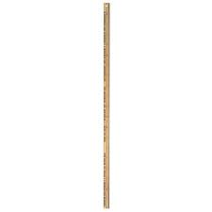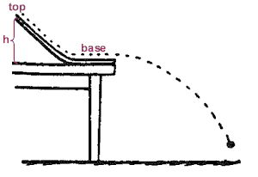

**LAUNCHER**

**X**

**D**

**h**

The table below shows the data they gathered over several trials, where they used successively larger launch speeds **u** and measured the height **h** at which the ball bearing passed by the ruler.

|  |  |  |
| --- | --- | --- |
| Launch speed **u** (m s-1) | Height (m) | 1/u2 (m-2 s-2) |
| 1.6 | 0.11 |  |
| 2.0 | 0.40 |  |
| 2.4 | 0.56 |  |
| 2.8 | 0.66 |  |
| 3.2 | 0.72 |  |
| 3.6 | 0.76 |  |

The general relationship between vertical displacement Y, horizontal displacement X and speed u for an object launched at angle  to the horizontal is given by

The relationship the students deduced linking speed u and height h for their experiment was

(a) Show how the students deduced their modified relationship, equation 2, for a launch angle of 0° from equation1. You must show all the steps in your reasoning. (3 marks)

(b) Complete the third row of the column. Use an appropriate number of significant figures. (2 marks)

(c) Draw a graph of h on the y-axis and 1/u2 on the x-axis. (an additional copy of the graph paper is available at the back of this paper if needed). Draw a line of best fit. (4 marks)

(d) The students estimated that their values for height h were accurate to ± 1 cm while the launch speed u was accurate to ± 0.1 m/s. Using these estimates calculate the **uncertainty** in both the vertical and horizontal variables and **plot** error bars on the graph, for the point where height h = 40 cm **only**. (3 marks)

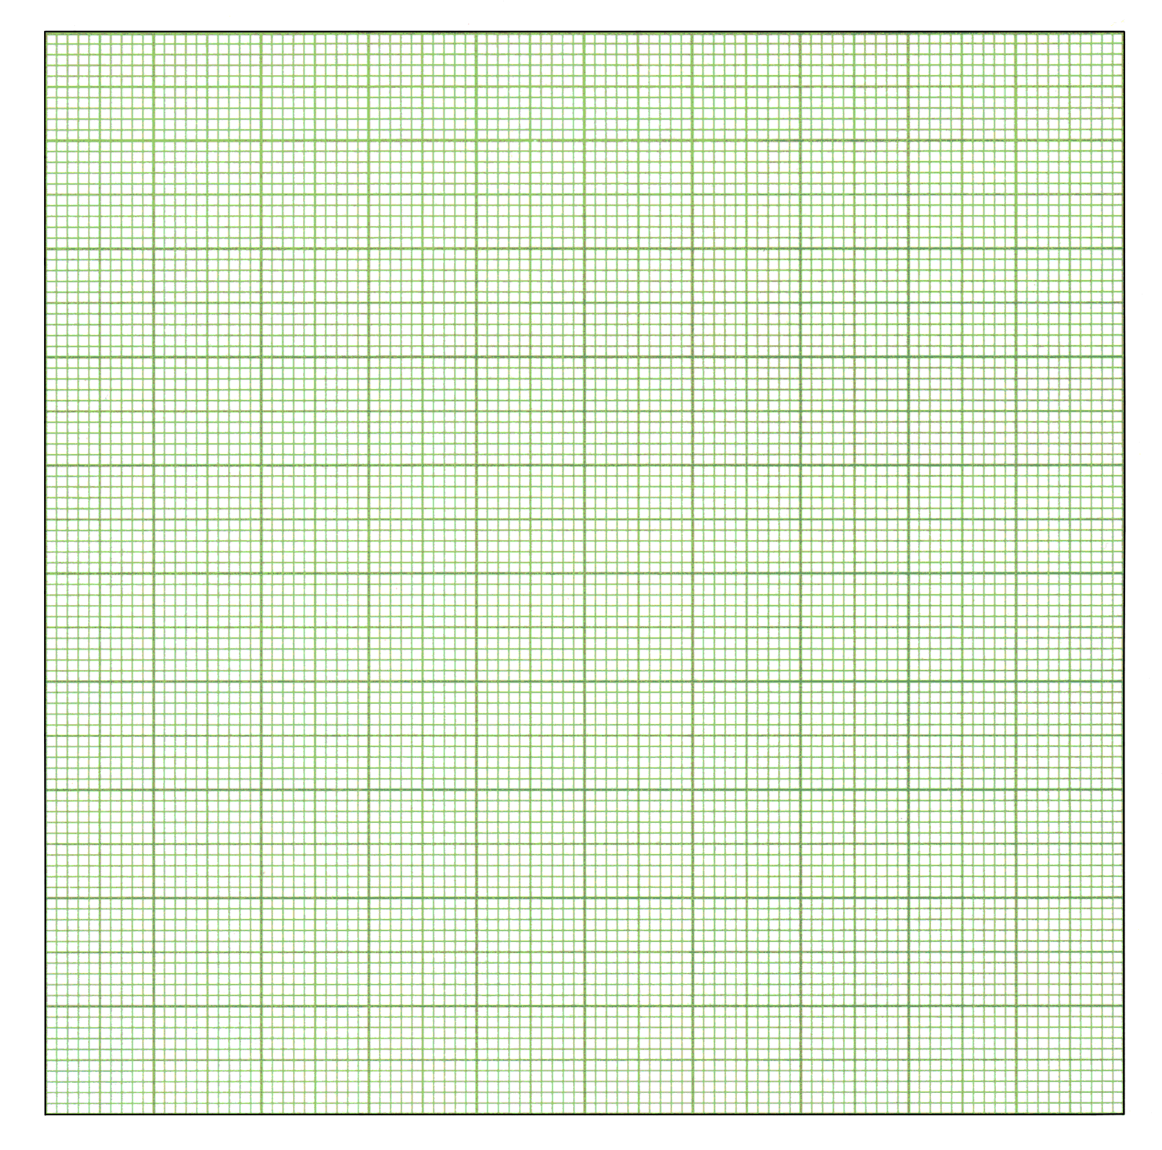

(e) Determine the gradient of the graph. You must show on your graph how you have determined the gradient and include the unit for the gradient. Use an appropriate number of significant figures. (4 marks)

(f) Calculate the fixed distance X that the ball bearing travelled horizontally from the edge of the table. (2 marks)

(g) From your graph, find

(i) the height D of the table (1 mark)

(ii) the minimum launch speed needed for the ball bearing to reach the metre ruler while still in the air (before hitting the floor) (2 marks)

**Question 22** **LASERS (15 marks)**

The word 'laser' stands for 'Light Amplification by Stimulated Emission of Radiation'. A laser is an instrument made of a certain material that can be stimulated, by an external energy source, to emit light. Light from everyday sources, such as a light bulb, is produced in a haphazard process called spontaneous emission that gives an incoherent source of light (the photons have a random phase difference), which is then emitted in all directions.

In the Bohr atomic model, electrons orbit the nucleus with a definite energy, which increases with distance from the centre of the atom. Most atoms are in the ground state with electrons in the lowest energy level - this distribution is called a normal population. If energy is supplied to the atoms then electrons can be forced to higher energy levels (Figure 1) and the atoms are said to be in an excited state. For most substances the absorbed energy is emitted 'spontaneously' (Figure 2) in a very short time, typically less than 10-8 s, as a photon of energy h.

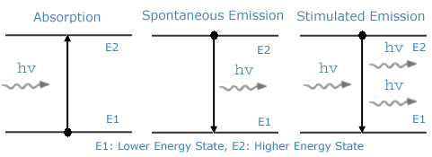 **Figure 1 Figure 2 Figure 3**

A laser on the other hand requires a substance that has a metastable state (an energy level in which an electron will remain for a time of the order of 10-3 s or longer) and atoms that are in an inverted population (more atoms are in the excited state than in the ground state).

These two conditions are necessary so that the process of stimulated emission can cause a coherent beam of light.

The stimulated emission process is shown above in Figure 3. When a photon of light of the same energy as the difference between the ground state and excited state hits an excited atom it causes the electron to fall back down to the ground state, emitting light of the same frequency that is in phase with the first photon and travels in the same direction. These photons strike other excited atoms causing an avalanche of photons with the same wavelength and in phase. A monochromatic laser beam is formed by having a resonating tube that has mirrors at each end, one fully reflecting, the other partially reflecting, which allows a small percentage of the photons to pass through.

The excitation of the atoms in a laser can be done in several ways to produce the necessary inverted population. In a ruby laser, the lasing material is a ruby rod consisting of Al2O3 with a small percentage of aluminium (Al) atoms replaced by chromium (Cr) atoms. The Cr atoms are the ones involved in lasing. The Cr atoms are excited by strong flashes of light of wavelength 540 nm, which 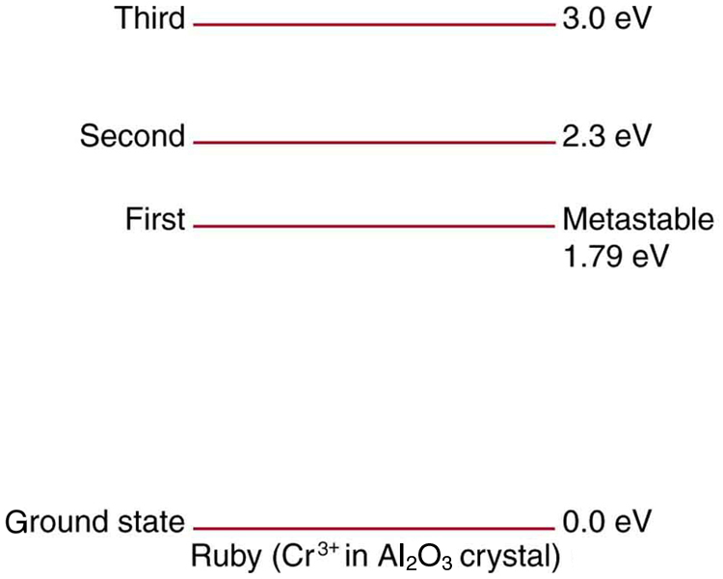correspond to a photon energy of 2.3 eV. As shown in Figure 4 below, the atoms are excited from the ground state to the second excited state. This process is called optical pumping. The atoms quickly decay either back to the ground state or to the intermediate first excited state, which is metastable with a lifetime of about 3 x 10-3 s. With strong pumping action an inverted population can be formed. As soon as a few atoms in the metastable state jump down to the ground state they emit photons that produce stimulated emission and the lasing action begins. A ruby laser thus emits a beam whose photons have energy 1.79 eV and a wavelength of 694.5 nm (or "ruby-red" light).

**Figure 4**: Energy levels of

chromium in a ruby laser.

(a) What are the main differences between an everyday light source and a laser? (2 marks)

(b) Describe the difference between a normal population of atoms and an inverted population of atoms. (2 marks)

(c) Briefly describe the two conditions that are necessary for stimulated emission to take place. (3 marks)

(d) How does the stimulated emission process produce a coherent beam of light? (3 marks)

(e) To what part of the electromagnetic spectrum does the transition from the second excited state to the intermediate first metastable excited state in the ruby laser (Figure 4) correspond? What implication does this have on the operation of the laser? (3 marks)

(f) What is the theoretical maximum efficiency of the ruby laser? (2 marks)

**End of Section Three - End of Questions**

Additional Working Space

Additional Working Space

Additional Graph Paper

